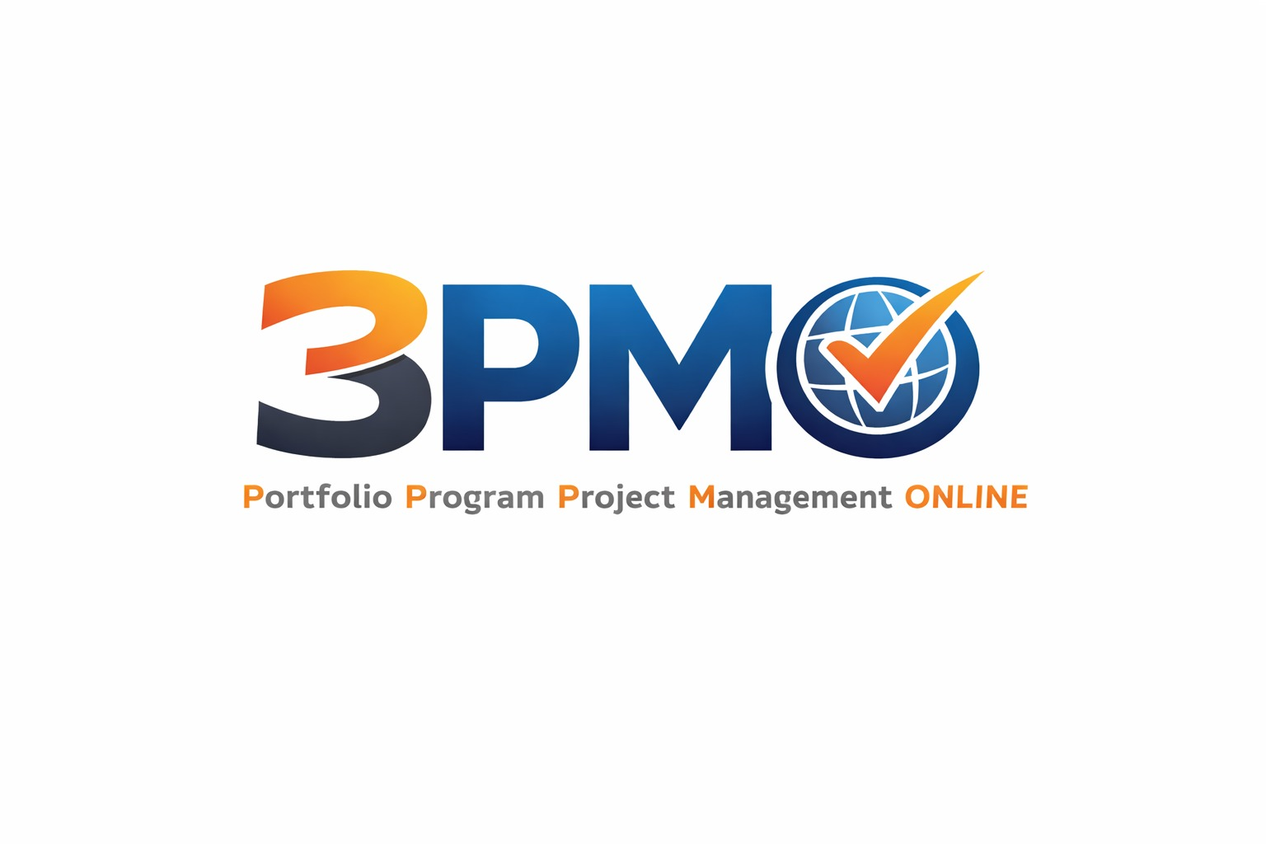

Portfolio Management Plan

Defining How the Portfolio Will Be Managed, Monitored, and Controlled

Organization: | [Organization Name]
Portfolio Name: | [Portfolio Name]
Document Version: | v1.0
Prepared By: | [Author Name]
Reviewed By: | [Reviewer Name]
Approved By: | [Approver Name]
Date: | [DD Month YYYY]
Classification: | Confidential / Internal Use

Revision History

Version | Date | Author | Description of Changes
1.0 | [DD/MM/YYYY] | [Author] | Initial draft

Table of Contents

[Update Table of Contents: References → Update Table → Update Entire Table]

1. Introduction

1.1 Purpose
The Portfolio Management Plan defines the approach, processes, roles, and responsibilities for managing this portfolio throughout its lifecycle. It serves as the primary reference document for all portfolio management activities and decisions.
1.2 Portfolio Overview
Portfolio Name: | [Portfolio Name]
Portfolio ID: | [ID]
Portfolio Manager: | [Name, Title]
Portfolio Sponsor: | [Name, Title]
Plan Version: | v1.0
Effective Date: | [DD Month YYYY]
Next Review Date: | [DD Month YYYY]

1.3 Relationship to Other Documents
This plan is subordinate to the Portfolio Charter and should be read in conjunction with the Portfolio Strategic Plan, Portfolio Roadmap, and individual Component Management Plans.
2. Portfolio Governance

2.1 Governance Framework
Describe the overall governance framework for this portfolio, including the governance bodies, their mandates, meeting cadences, and decision-making processes.
2.2 Roles and Responsibilities
Role | Name | Key Responsibilities | Authority Level
Portfolio Sponsor | [Name] | Strategic direction, executive escalation, resource commitment, final approval on major decisions | Full
Portfolio Manager | [Name] | Portfolio planning, execution oversight, reporting, stakeholder management, risk management | Operational
Steering Committee | [Names] | Portfolio prioritization, strategic alignment review, issue escalation, investment decisions | Strategic
Portfolio Analyst | [Name] | Data collection, performance reporting, dashboard management, financial tracking | Advisory
Component Managers | [Names] | Component-level delivery, status reporting, risk and issue escalation | Component

2.3 Portfolio Review Cadence
Review Type | Frequency | Participants | Purpose | Output
Portfolio Status Review | Monthly | Portfolio Manager, Analysts | Monitor performance, update dashboards | Status Report
Portfolio Steering Review | Quarterly | Steering Committee, Portfolio Manager | Strategic alignment, prioritization, investment decisions | Decision Log
Annual Portfolio Review | Annually | All stakeholders | Strategic realignment, budget planning, roadmap update | Updated Portfolio Plan
Ad Hoc Review | As needed | Relevant parties | Address critical issues or opportunities | Action Log

3. Portfolio Strategic Management

3.1 Strategic Alignment Process
Describe the process by which portfolio components are evaluated for strategic alignment, including the criteria used, the scoring methodology, and the frequency of alignment reviews.
3.2 Portfolio Prioritization
Define the prioritization framework used to rank and sequence portfolio components. Include the scoring criteria, weighting, and the process for re-prioritization when strategic conditions change.
Prioritization Criterion | Weight | Description | Scoring Scale
Strategic Alignment | 30% | Degree of alignment to organizational strategic goals | 1–5
Financial Value / ROI | 25% | Expected return on investment and financial benefit | 1–5
Risk Level | 20% | Overall risk exposure (lower risk = higher score) | 1–5
Resource Feasibility | 15% | Availability of required resources and capabilities | 1–5
Time to Value | 10% | Speed at which benefits will be realized | 1–5

4. Portfolio Performance Management

4.1 Performance Measurement Framework
Describe the overall approach to measuring portfolio performance, including the use of Earned Value Management (EVM), benefits realization tracking, and balanced scorecard approaches.
4.2 Key Performance Indicators
KPI | Description | Formula / Method | Target | Frequency | Owner
Strategic Alignment Index | % of components aligned to strategic goals | Aligned / Total × 100 | ≥ 90% | Quarterly | [Owner]
Benefits Realization Rate | % of planned benefits delivered on schedule | Actual / Planned × 100 | ≥ 85% | Quarterly | [Owner]
Schedule Performance Index (SPI) | Portfolio-level schedule efficiency | EV / PV | ≥ 0.95 | Monthly | [Owner]
Cost Performance Index (CPI) | Portfolio-level cost efficiency | EV / AC | ≥ 0.95 | Monthly | [Owner]
Portfolio ROI | Return on total portfolio investment | (Benefits – Cost) / Cost | ≥ [X]% | Annually | [Owner]
Risk Exposure Score | Aggregate portfolio risk level | Weighted risk register | < [Threshold] | Monthly | [Owner]

4.3 Reporting Framework
Report Type | Audience | Frequency | Format | Owner
Portfolio Dashboard | Executive Leadership | Monthly | One-page visual | Portfolio Analyst
Portfolio Status Report | Steering Committee | Quarterly | Detailed report | Portfolio Manager
Component Status Summary | Portfolio Manager | Bi-weekly | Structured template | Component Managers
Benefits Realization Report | Sponsor, Steering Committee | Quarterly | Benefits register extract | Portfolio Manager
Annual Portfolio Report | All stakeholders | Annually | Comprehensive document | Portfolio Manager

5. Portfolio Risk Management

5.1 Risk Management Approach
Describe the portfolio-level risk management approach, including how risks are identified, assessed, responded to, and monitored. Distinguish between portfolio-level risks and component-level risks.
5.2 Risk Appetite and Thresholds
Risk Category | Risk Appetite | Threshold | Escalation Trigger
Strategic Risk | Low | [Threshold] | Steering Committee
Financial Risk | Low to Medium | [Threshold] | Portfolio Sponsor
Operational Risk | Medium | [Threshold] | Portfolio Manager
Reputational Risk | Very Low | [Threshold] | Executive Leadership

5.3 Risk Escalation Process
Define the process for escalating risks from the component level to the portfolio level, including the criteria for escalation, the escalation path, and the response timeframes.
6. Portfolio Financial Management

6.1 Budget Management Process
Describe how the portfolio budget is managed, including the budget approval process, budget monitoring approach, variance thresholds, and the process for reallocating funds between components.
6.2 Financial Controls
Control | Description | Threshold | Approver
Budget Variance Alert | Notify Portfolio Manager when variance exceeds threshold | ±5% | Portfolio Manager
Budget Reallocation (Minor) | Reallocation within approved component budget | < 10% of component budget | Portfolio Manager
Budget Reallocation (Major) | Reallocation between components | ≥ 10% of component budget | Steering Committee
New Budget Request | Request for additional portfolio funding | Any amount | Portfolio Sponsor

7. Portfolio Change Management

7.1 Change Control Process
Define the process for managing changes to the portfolio scope, budget, timeline, or component composition. Include the change request process, impact assessment requirements, and approval authorities.
Change Type | Impact Level | Approval Authority | Process
Component scope change | Low | Component Manager | Component change log
Component budget change < 10% | Medium | Portfolio Manager | Portfolio change request
Component addition / removal | High | Steering Committee | Formal change request + impact assessment
Portfolio scope change | Critical | Portfolio Sponsor | Formal change request + board approval

8. Stakeholder Engagement

8.1 Stakeholder Register
Stakeholder | Role / Organization | Interest | Influence | Engagement Strategy | Owner
[Name] | [Role] | High | High | Manage Closely | [Owner]
[Name] | [Role] | High | Low | Keep Informed | [Owner]
[Name] | [Role] | Low | High | Keep Satisfied | [Owner]
[Name] | [Role] | Low | Low | Monitor | [Owner]

8.2 Communication Plan
Communication | Audience | Content | Method | Frequency | Owner
Portfolio Dashboard | Executive Leadership | KPIs, status, financials | Email / Portal | Monthly | [Owner]
Steering Review Pack | Steering Committee | Full status, decisions needed | Meeting + slides | Quarterly | [Owner]
Component Manager Briefing | Component Managers | Portfolio priorities, changes | Meeting | Monthly | [Owner]
Stakeholder Newsletter | All stakeholders | Progress highlights, upcoming milestones | Email | Quarterly | [Owner]

9. Portfolio Lifecycle Management

9.1 Component Lifecycle Gates
Define the lifecycle gates (stage gates) that each portfolio component must pass through, the criteria for gate approval, and the process for components that fail to meet gate criteria.
Gate | Name | Criteria for Passage | Approver
Gate 0 | Proposal Screening | Strategic alignment confirmed, business case drafted | Portfolio Manager
Gate 1 | Initiation Approval | Charter approved, sponsor assigned, budget allocated | Steering Committee
Gate 2 | Planning Approval | Management plan approved, resources confirmed | Portfolio Manager
Gate 3 | Execution Approval | Deliverables on track, risks managed | Portfolio Manager
Gate 4 | Closure Approval | Deliverables accepted, benefits baseline set | Portfolio Sponsor

10. Plan Maintenance

Review Frequency: | Annual (or upon major portfolio change)
Review Owner: | [Portfolio Manager Name]
Approval Required: | Portfolio Sponsor + Steering Committee
Version Control: | Maintained in [Document Management System]
Distribution: | [Steering Committee, Component Managers, Sponsors]

11. Document Approval

Role | Name | Signature | Date
Portfolio Sponsor | [Name]
Portfolio Manager | [Name]
Steering Committee Chair | [Name]

