March 30, 2026
10 highly effective PPT presentation tips tailored specifically for college-level students (clear, practical, and easy to apply in class or assignments):

🎯 1. Start with a Strong Hook
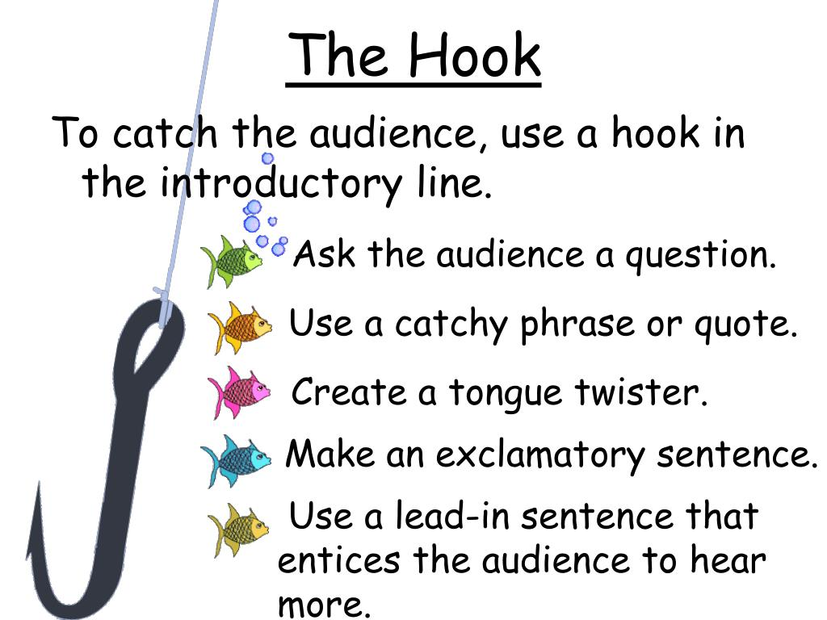

- Begin with a question, shocking fact, or short story
- Example: “Did you know 90% of startups fail within 5 years?”
👉 This immediately captures attention and sets context

📌 2. Follow a Clear Structure (3-Part Rule)

- 1) Introduction → 2) Main Content → 3) Conclusion
- Always include an agenda slide
👉 Helps audience follow your logic (very important for grading)

🎨 3. Keep Slides Visually Simple


- Use 6–7 lines max per slide
- Avoid paragraphs
👉 Slides are visual aids, not a script

🖼️ 4. Use High-Quality Visuals (Not Just Text)
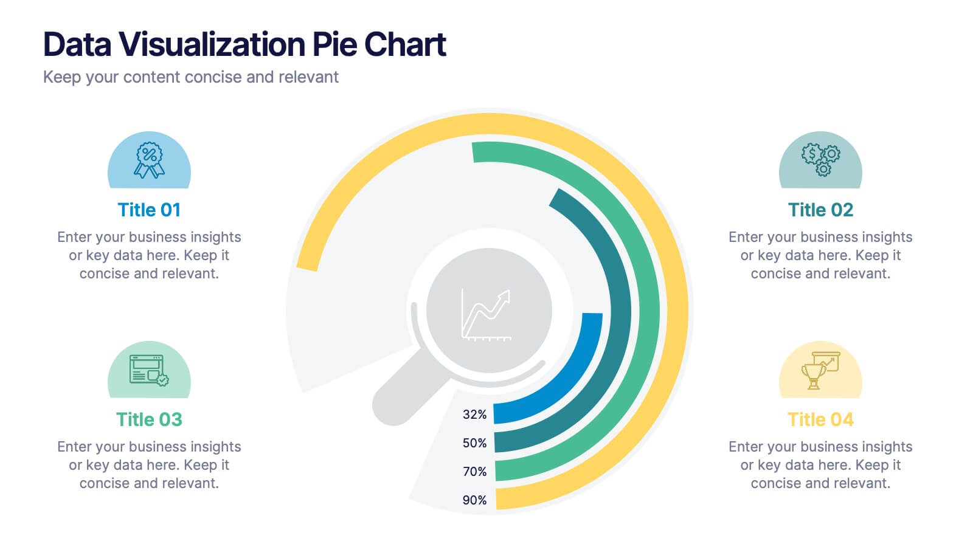
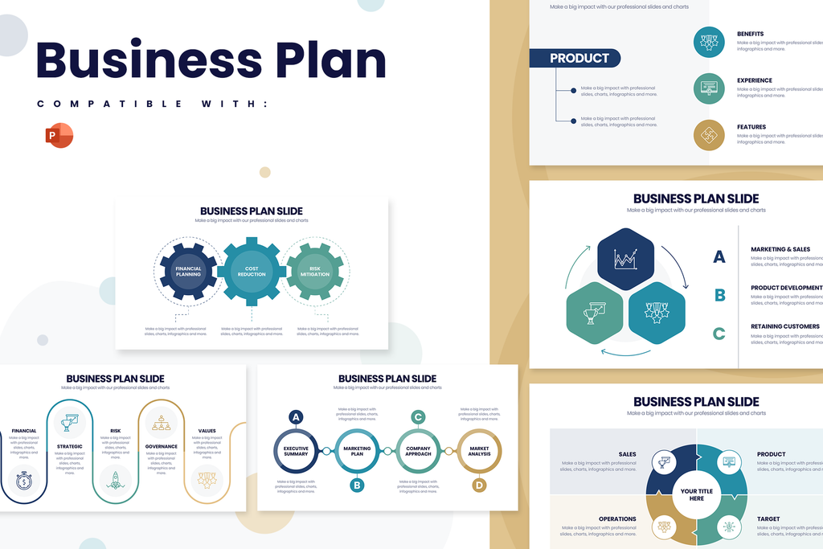
- Charts, icons, images > long text
- Especially useful for marketing, finance, strategy topics
👉 Improves understanding and retention

🔑 5. One Message Per Slide
- Each slide should answer one key question
- Example:
  - ❌ “Market size + competitors + strategy” in one slide
  - ✅ Separate slides for each
👉 Makes your argument clearer and more persuasive

🎤 6. Don’t Read—Explain
- Use slides as prompts, not scripts
- Maintain eye contact and natural speaking tone
👉 Professors evaluate delivery, not just content

⏱️ 7. Manage Time Strictly
- Rule of thumb: 1 slide ≈ 1 minute
- Practice beforehand (very important for grading)
👉 Going over time often reduces scores

📊 8. Use Real Examples (Critical for College Level)

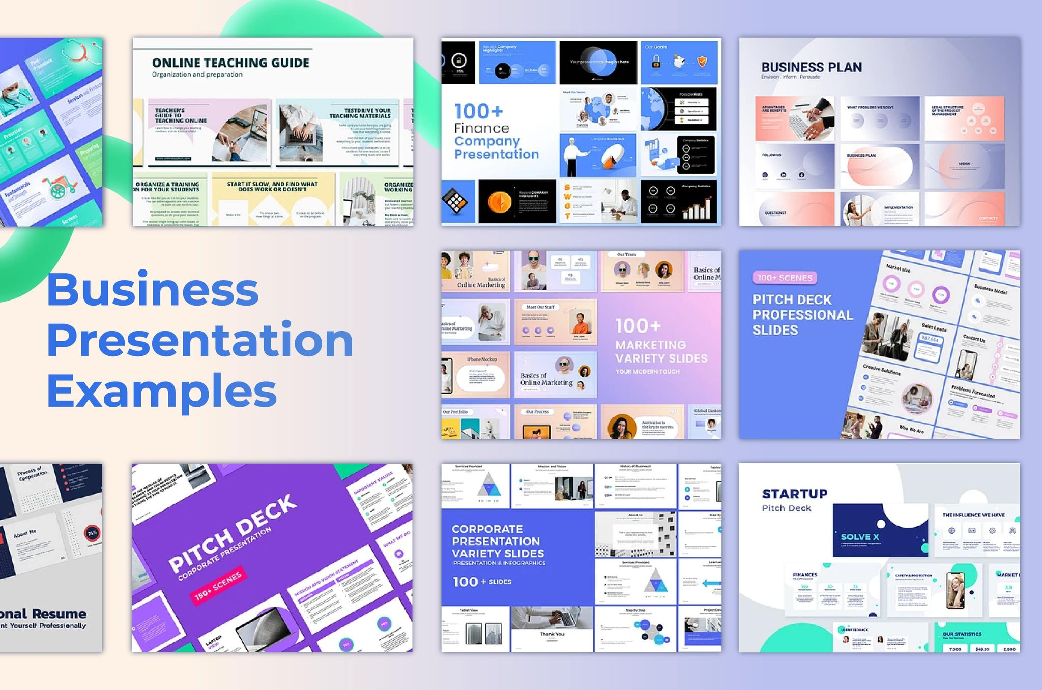

- Include real firms like:
  - Apple, Samsung, Tesla, or Korean firms (e.g., K-beauty brands)
👉 Shows analytical depth and practical understanding

🎯 9. Highlight Key Points (Don’t Hide Them)
- Use:
  - Bold text
  - Color contrast (e.g., red for key insight)
👉 Helps audience quickly grasp important ideas

🧾 10. End with a Strong Conclusion + Q&A
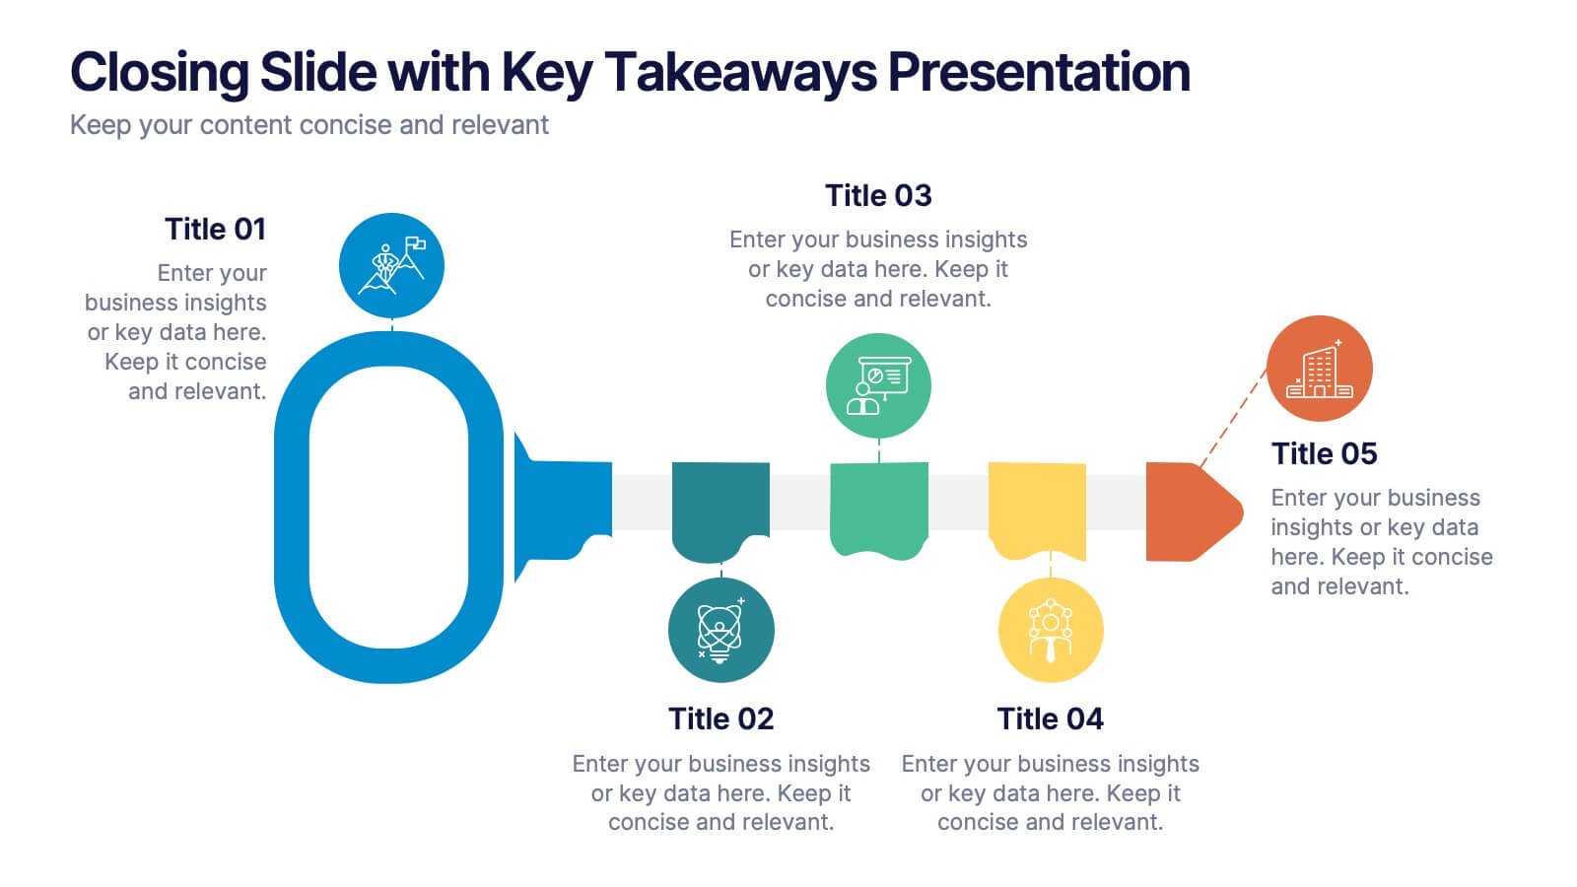

- Summarize 3 key takeaways
- Add a “Thank You / Q&A” slide
👉 “ Leaves a strong final impression “

Thank you for your great efforts !!!

