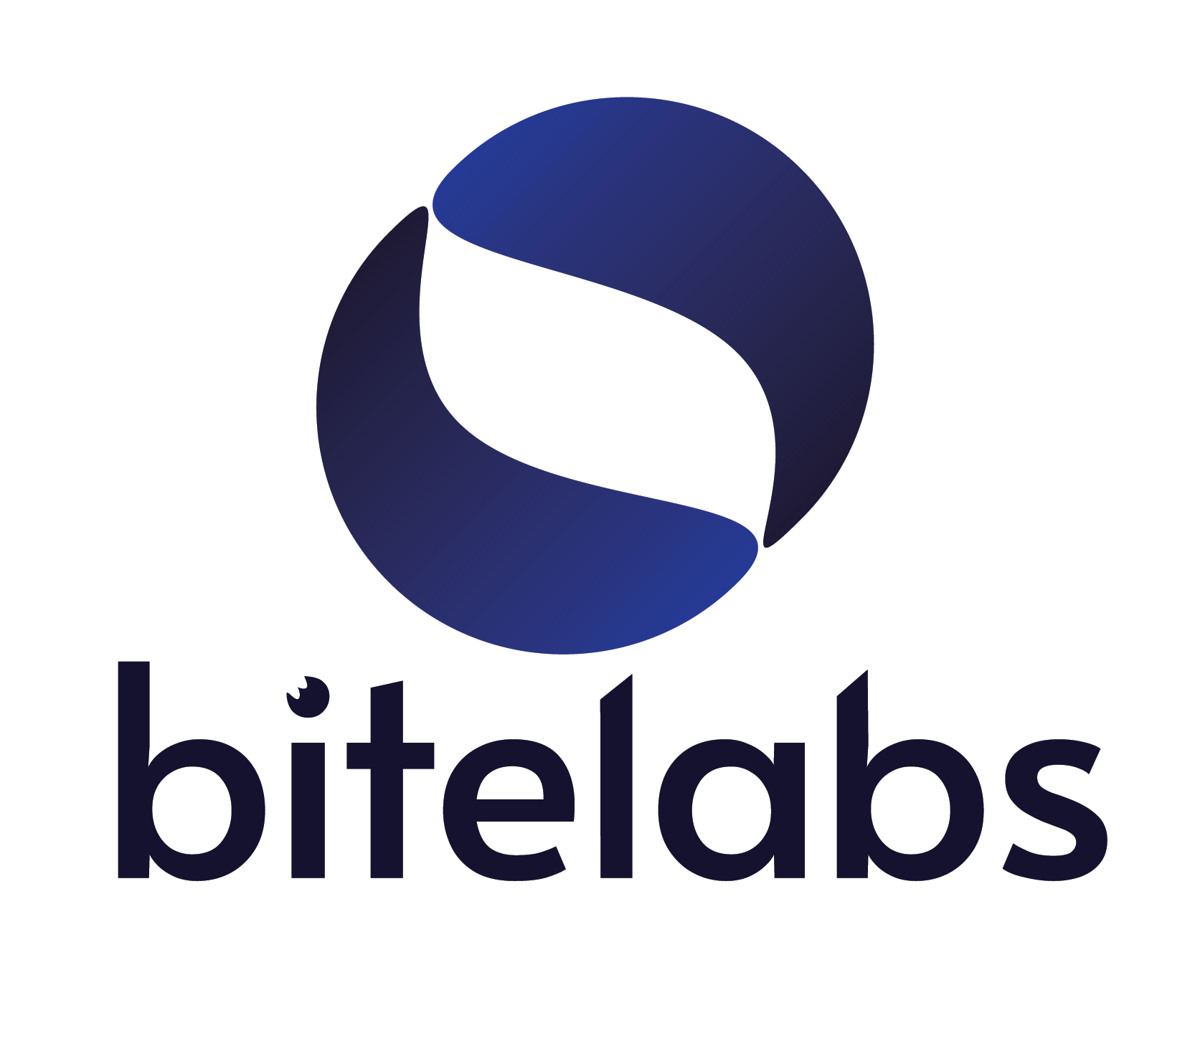
BiteLabs Digital Health, AI and Innovation Fellowship
The Old School House, West Street, Hampshire, PO17 6EA
www.bitelabs.io

Dr Azeem Alam, BEM FRSA
Founder, BiteWorld Ltd
azeem@bitelabs.io

[INSERT DATE]

RE: [TRAINEE FULL NAME]

BiteLabs Digital Health, AI and Innovation Fellowship: Pre-Application Support for NHS Study Budget / Aspirational Funding

To Whom It May Concern,

I am writing in support of [TRAINEE NAME]'s application for NHS study budget or aspirational funding to attend the BiteLabs Digital Health, AI and Innovation Fellowship. [TRAINEE NAME] has expressed strong interest in the upcoming cohort of the programme. I am writing to provide supporting evidence for their funding application and to confirm the programme's alignment with NHS and GMC training requirements.

This training sits directly within the NHS Fit for the Future 10-Year Health Plan (July 2025) digital workforce agenda (see below).

About the BiteLabs Fellowship
BiteLabs Digital Health is the UK's leading clinician-led digital health fellowship, with over 800 alumni across UK and US cohorts. It is supported by over 50 organisations and has collaborated with key institutions, such as the Royal College of General Practitioners and the Royal Society of Medicine, with advisors from organisations including Google Health, YouTube Health, Accurx, and MANUAL. It is designed specifically for NHS clinicians who wish to develop practical, applied skills in digital health, service improvement, and health technology, capabilities that are now central to the NHS's transformation agenda. BiteLabs is a part of BiteWorld Ltd, an organisation that has trained over 250,000 clinicians and was included in the late Her Majesty’s New Years Honours List 2021 for services to healthcare education.

Programme Format and Time Commitment
The BiteLabs Fellowship is 8 weeks in duration, delivered largely online and part-time, and structured to run alongside active clinical roles. The time commitment is approximately 4–6 hours per week, with the majority of live sessions scheduled outside core NHS clinical hours. Attendance does not require any time away from clinical duties and has no impact on the trainee's rota. The programme is therefore fully compatible with study leave restrictions and does not require release from clinical commitments. The programme fee is [FEE - AMEND DEPENDING ON REMOTE OR HYBRID].

Curriculum and Learning Outcomes
Over 8 weeks, participants develop capabilities across six curriculum domains:
- Clinical Product Management and Workflow Design
- Lean Canvas methodology: problem statements and hypotheses
- User research and evidence-based data gathering
- Regulatory and governance in digital health and AI
- Artificial Intelligence in clinical practice and medical content creation
- Product commercialisation and implementation strategy

On completion, the trainee will produce a digital health project addressing a real-world NHS challenge which will be marked and assessed. This provides portfolio-ready evidence suitable for ARCP and annual appraisal, and a structured future approach to implementing change within their clinical setting.

Alignment with the NHS 10-Year Health Plan
The NHS Fit for the Future 10-Year Health Plan (July 2025) explicitly identifies artificial intelligence, data, digital capability, and service transformation as strategic priorities, stating a national ambition for the NHS to become the world's most AI-enabled health service. The Plan identifies AI as one of its 'five big bets' and calls for significant investment in building a digitally capable NHS workforce. It further requires NHS organisations to invest meaningfully in service transformation, with the ambition for care delivery to shift from analogue to digital across all settings.

Participation in the BiteLabs Fellowship directly addresses this agenda by equipping clinicians with the practical tools to identify, design, and implement digital health improvements in their own departments. Investment in this training represents a direct contribution to the NHS digital workforce development priorities set out in the 10-Year Plan.

Alignment with GMC Generic Professional Capabilities
The BiteLabs curriculum maps directly to several GMC Generic Professional Capabilities (GPC) domains that are required for progression through postgraduate training and CCT recommendation. Specific domain alignment includes:

- Domain 7: Leadership and Team Working: Developing and implementing service improvement proposals; stakeholder engagement and change management.
- Domain 8: Patient Safety and Quality Improvement: Structured quality improvement methodology; data-driven clinical workflow analysis.
- Scholarship and Research: Evidence-based approach to digital health problems; project methodology and output.

These capabilities are required across all specialty curricula. Participation in this fellowship will support the trainee’s clinical training and will generate evidence demonstrable at ARCP.

The trainee’s application is a testament to their commitment to the NHS's digital future and to delivering improved patient care within their department. We are confident that this training will generate direct, measurable value for their clinical practice and their organisation. We strongly support their application for aspirational or study budget funding and would be happy to provide any further information required.

Yours sincerely,

Dr Azeem Alam, BEM FRSA
Founder, BiteWorld Ltd
NHS Radiology Registrar
Honorary Clinical Research Fellow, Imperial College London
Advisor, King's Health Partners Digital Health Hub

Email: azeem@bitelabs.io
LinkedIn: linkedin.com/in/azeemalam
Website: www.bitelabs.io

