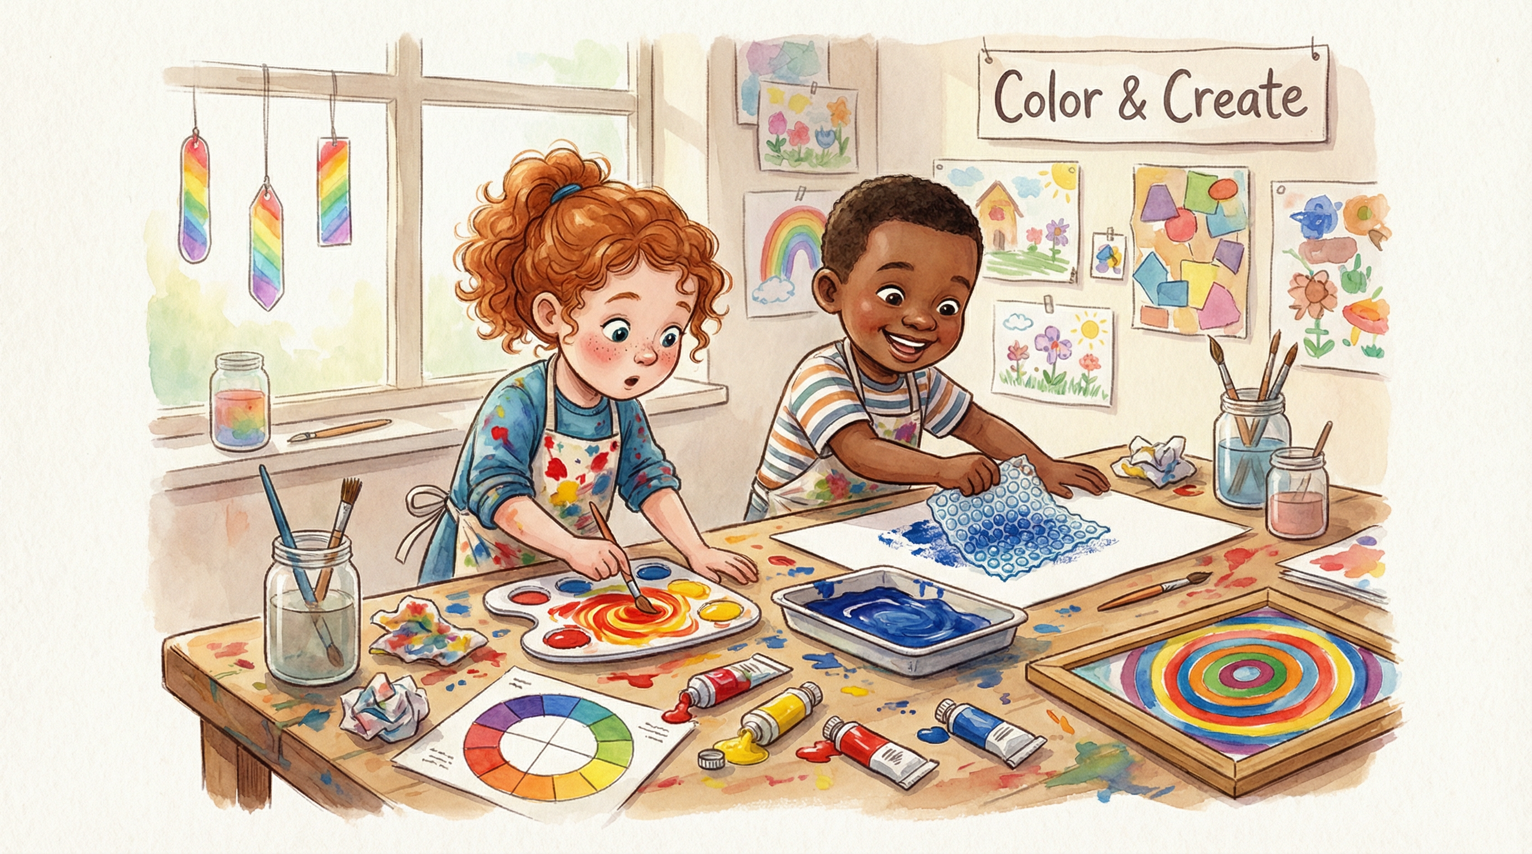
Color & Create
Mix It, Make It, Marvel at It!
🎨 Art in Color · Pre-K to Kindergarten · 5 Days · 9 Activities · 10 Printables

LESSON OVERVIEW

Color & Create
Mix It, Make It, Marvel at It!

Color & Create is a full-day (or full-week) exploration of colour, art, and creative expression for young learners. Children discover primary and secondary colours through hands-on mixing, painting with unusual tools, exploring famous artists, and making their own masterpieces. Every activity is rooted in process art — the joy is in the making, not the outcome.

🎨 Art in Color | 👶 Pre-K to K | 📅 5 Days | 📄 10 Printables

5-DAY LESSON ARC

The Week at a Glance
DAY | THEME | FOCUS
Day 1 | Primary Colours | Red, yellow, blue — the building blocks of all colour
Day 2 | Colour Mixing Magic | What happens when two colours meet?
Day 3 | Painting with Unusual Tools | Art beyond the brush
Day 4 | Colours in Nature | Observing colour in the world around us
Day 5 | Our Colour Gallery | Celebrating and sharing our creations

9 HANDS-ON ACTIVITIES

Activities

🔴 COLOUR LITERACY
Red, Yellow & Blue — The Big Three!
Introduce the three primary colours using real objects from a mystery bag. Pull out items one at a time — a red apple, a yellow banana, a blue cup — and sort them onto large colour mats. Ask: 'Can you find something red in our classroom?' Builds colour vocabulary, sorting skills, and real-world observation.
Materials: Red, yellow, and blue sorting mats (Printable #01) · Mystery bag · Assorted red/yellow/blue classroom objects
📄 Printable #01

🎨 SCIENCE & ART
What Colour Does It Make?
Give each child a white ice cube tray or muffin tin with red, yellow, and blue paint in three sections. Using eyedroppers or cotton swabs, children mix pairs of colours and record what they discover. Red + Yellow = ? Yellow + Blue = ? Red + Blue = ? This is the 'aha!' moment of the whole lesson.
Materials: Ice cube trays or muffin tins · Red/yellow/blue paint · Eyedroppers or cotton swabs · Colour Mixing Chart (Printable #02)
📄 Printable #02

🫧 ART PROJECT
Pop! Bubble Wrap Prints
Dip sheets of bubble wrap in paint and press them onto paper to create stunning textured prints. Children can layer colours, overlap patterns, and mix shades. The result looks like stained glass or a mosaic. Discuss: 'What shapes do you see? What happens when the colours overlap?'
Materials: Bubble wrap (various sizes) · Tempera paint in multiple colours · Large paper · Bubble Print Observation Sheet (Printable #03)
📄 Printable #03

🟡 FAMOUS ARTISTS
Circles Like Kandinsky
Show children Wassily Kandinsky's 'Squares with Concentric Circles' (1913). Discuss: 'What shapes do you see? How do the colours make you feel?' Children create their own concentric circle artwork using paint, oil pastels, or torn paper collage. Introduce the idea that art can express feelings through colour.
Materials: Kandinsky Circles Template (Printable #04) · Paint or oil pastels · Image of Kandinsky's artwork · Paper plates for mixing
📄 Printable #04

🌈 MATH & ART
Build a Colour Wheel
Children arrange colour swatches, paint chips, or torn magazine pieces in rainbow order around a large circle template. Discuss warm colours (red, orange, yellow) vs cool colours (blue, green, purple). Introduce the concept of complementary colours — colours that sit opposite each other on the wheel.
Materials: Colour Wheel Template (Printable #05) · Paint chips or magazine scraps · Glue sticks · Crayons
📄 Printable #05

🌿 NATURE & SCIENCE
Colours in the Wild
Take children outside with their Nature Colour Hunt cards. They match colours on their card to things they find in nature — a red berry, a yellow flower, a brown stick, a grey stone. Back inside, press any flowers or leaves found onto the Colour Collection Page. Builds observation, vocabulary, and connection to the natural world.
Materials: Nature Colour Hunt Card (Printable #06) · Collection bags · Magnifying glasses
📄 Printable #06

🖌️ ART & SCIENCE
Magic Crayon Resist
Children draw bold shapes or patterns with white or light-coloured wax crayons on white paper. Then they paint over the entire page with watercolour wash — and watch the crayon drawings 'magically' appear! Discuss: 'Why does the crayon resist the paint?' Introduces the concept of wax and water repelling each other.
Materials: White wax crayons or oil pastels · Watercolour paints · Brushes · Watercolour Resist Recording Sheet (Printable #07)
📄 Printable #07

💜 SOCIAL-EMOTIONAL
How Does This Colour Make You Feel?
Discuss how different colours can make us feel different emotions — red can feel exciting or angry, blue can feel calm or sad, yellow can feel happy and warm. Children choose a colour that matches how they feel today and create a collage using torn paper, stickers, and drawings in that colour family.
Materials: Colour Feelings Chart (Printable #08) · Coloured paper · Magazines · Stickers · Glue sticks
📄 Printable #08

🍓 KIDS IN THE KITCHEN
Colour Your Snack!
Mix food colouring into cream cheese, yoghurt, or frosting to create primary colours. Then let children mix their own secondary colours — orange, green, and purple — and spread them on crackers or bread. Eat the rainbow! Discuss: 'What colour did you make? What did you mix together?'
Materials: White cream cheese or plain yoghurt · Red/yellow/blue food colouring · Crackers or bread · Plastic knives · Colour My Snack Recipe Card (Printable #09)
📄 Printable #09

7 TIPS FOR TEACHERS

Educator Tips

1 | How do I set up the classroom for this lesson?  Set up five colour stations before children arrive: a sorting station with objects and mats, a mixing station with paint trays and eyedroppers, an art station with bubble wrap and paint, a nature table with collected items, and a reflection corner with the Colour Journal. Label each station with a large colour-coded sign. Lay down a plastic tablecloth or newspaper at the painting stations.

2 | How do I introduce Kandinsky to young children?  Show a large printed image of 'Squares with Concentric Circles' and simply ask: 'What do you see? What do you feel?' Young children respond naturally to colour and shape without needing art history. Keep the introduction to 3–4 minutes. The goal is wonder, not knowledge. Say: 'This artist believed that colours have feelings — just like us!'

3 | How can I differentiate for mixed ability groups?  For younger learners (ages 3–4): focus on sensory colour mixing — squishing paint in zip-lock bags, finger painting, and tearing coloured paper. Keep activities open-ended with no 'right' outcome. For older learners (ages 5–6): introduce colour vocabulary (hue, shade, tint), challenge them to mix a specific colour from memory, and encourage labelling their artwork with colour words.

4 | How long does the full lesson take?  The complete 5-day lesson runs approximately 1–2 hours per day. A single-day version works well with: Primary Sorting (15 min) → Colour Mixing (20 min) → Bubble Wrap Printing (25 min) → Kandinsky Circles (25 min) → Colour Snack (20 min). The Nature Colour Hunt and Watercolour Resist can be added as enrichment or homework.

5 | What if I don't have all the art supplies?  Every activity has a simple alternative. No bubble wrap? Use crumpled foil, sponges, or forks. No oil pastels? Use white crayon for the resist activity. No watercolour paints? Dilute tempera paint with water. No ice cube trays? Use paper plates divided into sections with tape. The lesson is designed to be flexible and low-cost.

6 | What's the best way to display and celebrate the children's artwork?  On Day 5, host a 'Colour Gallery' walk where children's artwork is displayed around the room. Give each child a sticky note to leave a compliment on a classmate's piece. Photograph each child with their favourite piece and send it home. The My Colour Journal (Printable #10) makes a beautiful keepsake to take home at the end of the week.

7 | Which early learning standards does this lesson address?  This lesson supports standards across multiple domains: Visual Arts (colour theory, process art, famous artists, creative expression), Language & Literacy (colour vocabulary, descriptive language, labelling artwork), Mathematics (sorting, patterns, colour matching, graphing), Science (colour mixing, light and pigment, wax resist), and Social-Emotional Learning (expressing feelings through colour, appreciating others' creativity, building confidence as an artist).

10 READY-TO-PRINT ACTIVITY SHEETS

Printable Reference Guide

#01 | Primary Colour Sorting Mats  Colour Literacy | Three large sorting mats (red/yellow/blue) with picture cards to sort by colour.
#02 | Colour Mixing Chart  Science & Art | Grid chart: mix two colours and record the result. 6 combinations with drawing boxes.
#03 | Bubble Print Observation Sheet  Art Project | Large blank frame for bubble print, plus 'I used these colours' recording boxes.
#04 | Kandinsky Circles Template  Famous Artists | 4 large concentric circle outlines ready to colour. Mini Kandinsky bio for the teacher.
#05 | Colour Wheel Template  Math & Art | Blank 12-section colour wheel with primary/secondary labels. Warm/cool sorting guide.
#06 | Nature Colour Hunt Card  Nature & Science | Bingo-style grid with 9 colour squares to match in nature.
#07 | Watercolour Resist Recording Sheet  Art & Science | 'Before' and 'After' drawing boxes. Sentence starter: 'The crayon resisted because...'
#08 | Colour Feelings Chart  Social-Emotional | 8 colour circles with feeling word prompts. 'Today I feel _____ because my colour is _____.'
#09 | Colour My Snack Recipe Card  Kids in the Kitchen | Step-by-step illustrated recipe for colour-mixing snack.
#10 | My Colour Journal  Reflection | Cover page + 5 daily reflection pages: favourite colour today, what I made, how I felt.

Color & Create · Print2Learn Collective · © 2025 Robyn B · All rights reserved
Lesson content developed with AI assistance and reviewed by Robyn B, early childhood educator.

