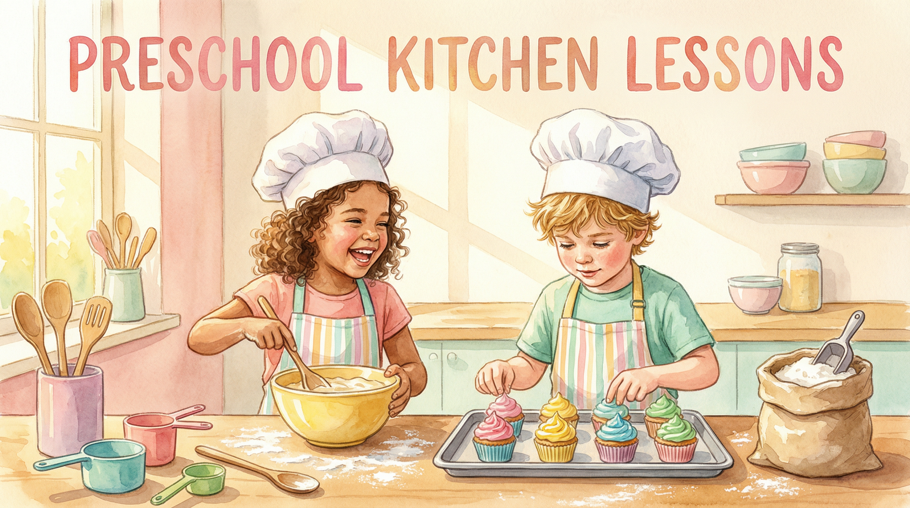

🍳 Cook Count Create
A Full Day of Kitchen Learning Fun
9  Activities | 10  Printables | Pre-K–K  Age Group | 1 Day  Duration

Cook Count Create is a complete, ready-to-teach preschool and kindergarten lesson that transforms your kitchen into a classroom for a full day of learning. Children cook, count, craft, and create their way through 9 hands-on activities that build language, maths, science, and creative arts skills — all while wearing their very own chef hats!
Includes 10 ready-to-print activity sheets. Print on standard letter paper. All activities use simple, affordable materials available in any classroom or home kitchen.
────────────────────────────────────────────────────────────

LESSON ACTIVITIES
9 Hands-On Activities
Each activity includes a materials list and a linked printable worksheet.
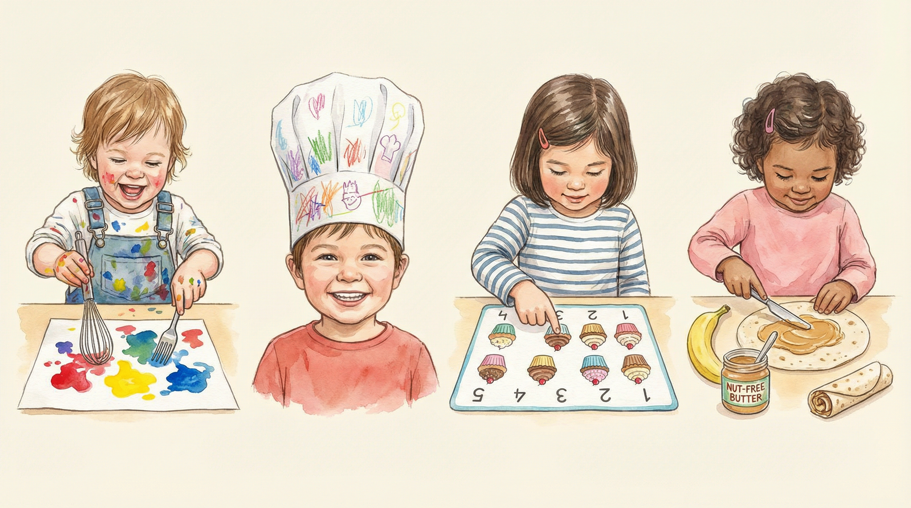

🗣️ [Circle Time] What's In My Kitchen? Show & Tell
Gather children in a circle. Show a food or kitchen-related item using real tools or printed cards. Invite students to name it, talk about what it does, and act it out. Builds expressive language, real-life connections, and curiosity.
📋 MATERIALS NEEDED:
• Kitchen Item Picture Cards (Printable #01)
• Real or play kitchen tools
• Large floor mat or pocket chart
⬇ Download Printable #01

✂️ [Pre-K Activity] Step-by-Step Recipe Sequencing
Use picture cards to walk children through a simple sandwich-making process. Children cut and glue steps in the correct order, supporting sequencing and early comprehension.
📋 MATERIALS NEEDED:
• Recipe Sequencing Cards (Printable #02)
• Glue sticks
• Scissors
⬇ Download Printable #02

🎨 [Art Project] Paint With Pancake Tools
Let kids dip real kitchen tools into paint and stamp or drag them across paper to make unique prints. After it dries, encourage them to decorate with drawn-on food or characters.
📋 MATERIALS NEEDED:
• Kitchen Tools Outline Page (Printable #03)
• Tempera or washable paint
• Whisks, spatulas, pastry brushes, forks
⬇ Download Printable #03

👨‍🍳 [Craft Activity] Make Your Own Chef Hat
Students decorate their own chef hats, cut them out, and staple to fit. They share their 'chef name' and introduce their kitchen superpower — stirring, chopping, measuring, or tasting!
📋 MATERIALS NEEDED:
• Chef Hat Template (Printable #04)
• White cardstock or construction paper
• Crayons, markers, stapler or tape
⬇ Download Printable #04

🧮 [Math Activity] Counting with Cupcakes
Set up mats with number prompts. Children count the correct number of cupcakes in each box. Add compare questions like 'Which has more?' to deepen understanding.
📋 MATERIALS NEEDED:
• Count the Cupcakes Mat 1–10 (Printable #05)
• Pretend cupcakes or printed pieces
• Number cards
⬇ Download Printable #05

🔬 [Science] Melting & Mixing: What Changes?
Compare how different substances change when added to warm water. Kids observe, stir, and record what melts or dissolves — building early scientific thinking.
📋 MATERIALS NEEDED:
• Mix & Melt Observation Sheet (Printable #06)
• 2 bowls
• Ice cubes, sugar, salt, flour
• Warm water
⬇ Download Printable #06

🫙 [Sensory Station] Measuring & Pouring Station
Children scoop and pour using dry grains and real tools. Encourage use of sensory vocabulary with printable labels as visual support.
📋 MATERIALS NEEDED:
• Sensory Vocabulary Cards (Printable #07)
• Dry rice or pasta
• Measuring cups and spoons
• Funnels, bowls, scoops
⬇ Download Printable #07

🎵 [Music & Movement] Move Like a Mixer!
Pull an action card and act it out — 'Whisk your arms!', 'Roll like dough!'. Add rhythm or music for movement exploration. Great for gross motor skills and imagination.
📋 MATERIALS NEEDED:
• Kitchen Action Cards (Printable #08)
• Music player or drum
• Open space
⬇ Download Printable #08

🍌 [Kids in the Kitchen] No-Cook Banana Roll-Ups
Students spread, roll, and slice their own banana roll-ups. Practice sequencing, safety, and descriptive words like roll, spread, and taste.
📋 MATERIALS NEEDED:
• Banana Roll-Up Recipe Card (Printable #09)
• Tortillas, bananas, nut-free spread
• Plastic knives
⬇ Download Printable #09

EDUCATOR TIPS
Tips for Teachers
Practical advice to make this lesson run smoothly in any setting.
❓ How should I prepare for this lesson?
Gather all materials the day before. Pre-cut sequencing cards and pre-portion sensory station supplies. Set up stations around the room so transitions are quick and children stay engaged. A 5-minute 'kitchen rules' circle before starting sets clear expectations.

❓ How do I handle nut allergies for the Banana Roll-Up?
Substitute any nut-free spread — sunflower seed butter, cream cheese, or plain yogurt all work beautifully. Always check with families before the lesson and have a safe alternative ready for any child with additional restrictions.

❓ How can I differentiate for mixed ability groups?
For younger or emerging learners, pre-cut the sequencing cards and focus on 1–5 counting on the cupcake mat. For advanced learners, extend with 'how many more?' comparison questions, ask them to write the steps in their own words, or challenge them to create their own recipe card.

❓ How long does the full lesson take?
The complete lesson is designed for a full day (approximately 5–6 hours with transitions). Each activity runs 20–35 minutes. For a half-day format, prioritise the Show & Tell circle, Counting Mat, Banana Roll-Up, and Kitchen Journal as your core four.

❓ Can I use this for a home setting or homeschool?
Absolutely! The activities scale beautifully for 1–4 children. Skip the pocket chart and do Show & Tell at the kitchen table. The sensory station works in a bin on the floor. The chef hat craft is a favourite for solo learners — let them decorate it over two sessions.

❓ What's the best way to print the activity sheets?
Print on standard 8.5×11 letter paper at 100% scale (no 'fit to page'). For the Chef Hat and Sequencing Cards, cardstock (65–80 lb) gives a sturdier result. Laminating the Action Cards and Vocabulary Cards lets you reuse them across multiple classes.

❓ Which early learning standards does this lesson address?
This lesson touches on NAEYC DAP principles and common Pre-K/K standards including: ELA (vocabulary, sequencing, oral language), Math (counting 1–10, one-to-one correspondence, comparison), Science (observation, prediction, recording), and Creative Arts (visual art, music & movement). Check your state's specific standards for exact alignment codes.

FREE PRINTABLES
10 Ready-to-Print Activity Sheets
Print on standard 8.5×11 letter paper at 100% scale. Cardstock recommended for craft activities.
#01 CIRCLE TIME  Kitchen Item Picture Cards  Name it, talk about it, and act it out! 12 illustrated kitchen tool cards. | #02 PRE-K ACTIVITY  Recipe Sequencing Cards  Cut out the 6 sandwich-making steps and glue them in the correct order.

#03 ART PROJECT  Kitchen Tools Outline Page  Dip real kitchen tools in paint and stamp them across the page. | #04 CRAFT ACTIVITY  Chef Hat Template  Decorate, cut out, and wear your very own chef hat with pride!

#05 MATH ACTIVITY  Count the Cupcakes Mat  Count the cupcake illustrations in each numbered box — 1 through 10! | #06 SCIENCE  Mix & Melt Observation Sheet  Record what happens when ice, sugar, salt, and flour meet warm water.

#07 SENSORY STATION  Sensory Vocabulary Cards  12 word cards — pour, scoop, measure, stir, and more — with definitions. | #08 MUSIC & MOVEMENT  Kitchen Action Cards  Pull a card and act it out — Whisk your arms! Roll like dough! Add music!

#09 KIDS IN THE KITCHEN  Banana Roll-Up Recipe Card  Step-by-step no-cook recipe card for kids to make their own banana roll-up. | #10 REFLECTION  My Kitchen Journal  Reflection page with drawing space, writing lines, feelings check-in, and star rating.

────────────────────────────────────────────────────────────
© Print2Learn · Cook Count Create · Pre-K to Kindergarten Lesson Plan
All printables are for personal and classroom use only. Not for resale or redistribution.
✨ Disclaimer: This lesson was created with the assistance of AI technology and the creative mind of Robyn B. All lesson content, activity design, and educational intent reflect original human creativity.

