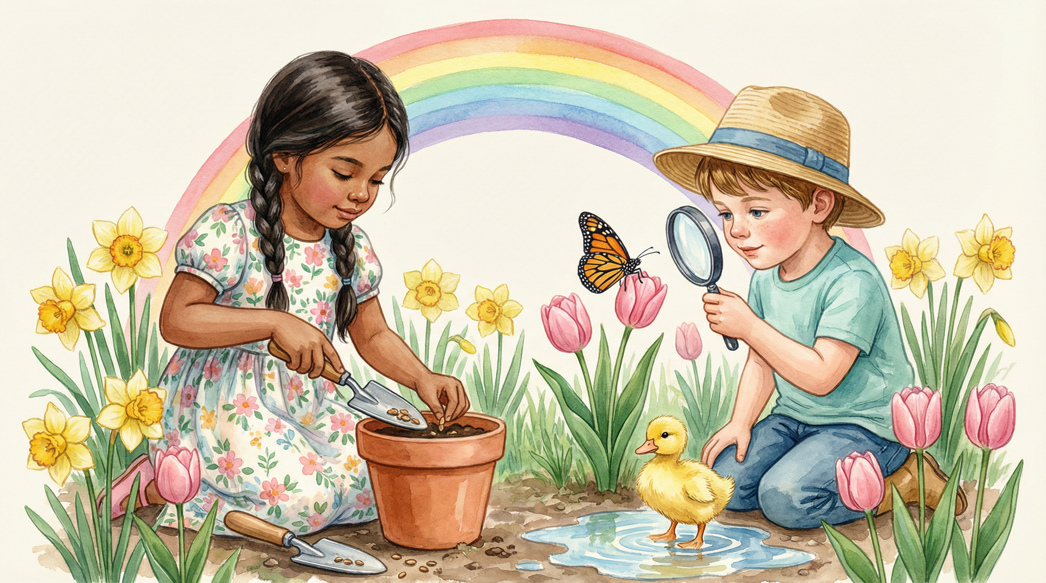

🌱 PRINT2LEARN COLLECTIVE — APRIL LESSON
🌿 Grow & Discover
Hello Spring! Puddles, Petals & Baby Animals
9  Activities | 10  Printables | Pre-K–K  Age Group | 5 Days  Duration

Grow & Discover invites children to step outside, get their hands dirty, and fall in love with the season that makes everything new again. Using simple materials — soil, seeds, real flowers, coffee filters, and pantry staples — each day becomes a spring science adventure built on direct observation, sensory exploration, and meaningful discovery.
Includes 10 ready-to-print activity sheets. Print on standard letter paper. All activities use simple, affordable materials available in any classroom, garden, or home.
────────────────────────────────────────────────────────────

LESSON ACTIVITIES
9 Hands-On Activities
Each activity includes a materials list and a linked printable worksheet.
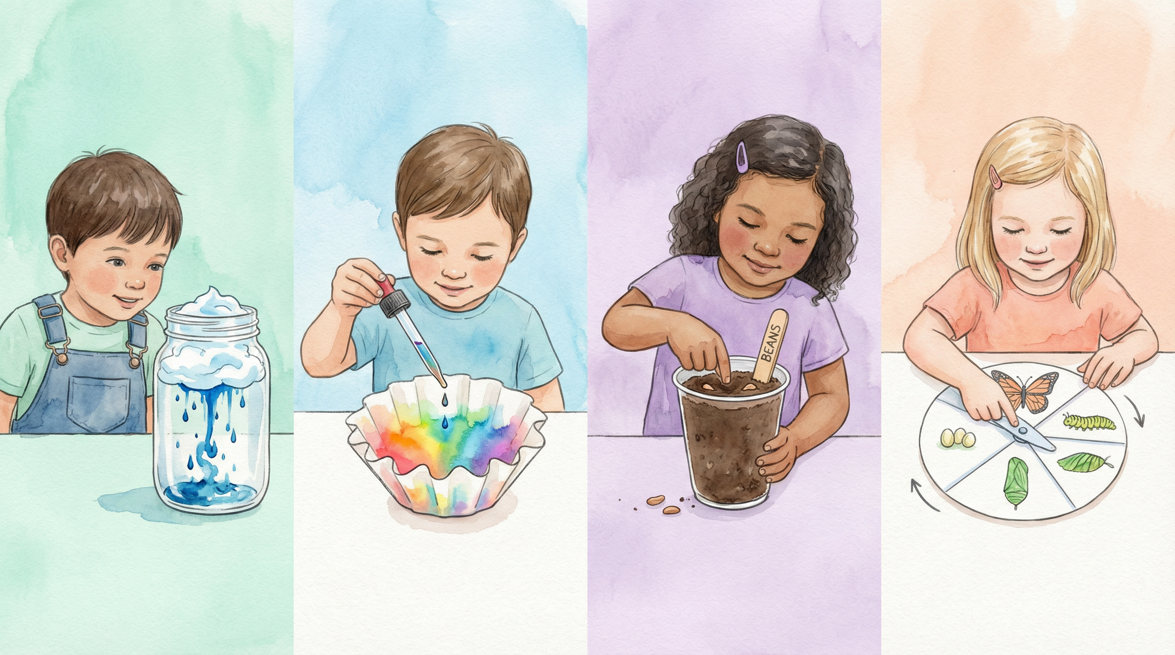

🌧️ [Water Science] Rain Cloud in a Jar
Fill a clear jar with water, add a shaving cream 'cloud', then slowly drip blue food colouring on top. Watch the 'rain' fall through when the cloud gets too heavy! Children record predictions and observations on the Science Mat.
📋 MATERIALS NEEDED:
• Clear jar
• Shaving cream
• Blue food colouring
• Eyedroppers
• Rain Cloud Science Mat (Printable #01)
⬇ Download Printable #01

🎨 [Art Project] Coffee Filter Rain Art
Flatten coffee filters and drop food colouring onto them using eyedroppers. Spray lightly with water and watch colours bleed and blend into stunning watercolour patterns. Once dry, cut into raindrop or umbrella shapes.
📋 MATERIALS NEEDED:
• Coffee filters
• Food colouring
• Eyedroppers
• Spray bottle with water
• Coffee Filter Art Template (Printable #02)
⬇ Download Printable #02

🔬 [Science] Absorption Investigation
Test paper towel, wax paper, fabric, and plastic wrap with eyedroppers of water. Which absorbs? Which repels? Record results on the investigation chart and discuss: 'Which material would make the best raincoat?'
📋 MATERIALS NEEDED:
• Paper towel, wax paper, fabric, plastic wrap
• Eyedroppers
• Water
• Absorption Investigation Chart (Printable #03)
⬇ Download Printable #03

🌸 [Plant Science] Walking Water Flowers
Place white carnations or celery stalks in cups of coloured water. Over the day, watch the colour travel up into the petals. Ask: 'How is the flower drinking? Where is the colour going?' This is magic that actually works!
📋 MATERIALS NEEDED:
• White carnations or celery stalks
• Food colouring
• Clear cups
• Parts of a Flower Labelling Page (Printable #04)
⬇ Download Printable #04

🌻 [Math Activity] Petal Count & Sort
Collect real or paper flowers and count petals. Sort by colour, size, or number of petals. Graph results: 'Which flower had the most petals?' Introduce the idea that flower shapes attract different insects.
📋 MATERIALS NEEDED:
• Real or paper flowers
• Petal Count & Sort Mat (Printable #05)
• Crayons
⬇ Download Printable #05

🌱 [Planting Science] Plant Your Own Spring Garden
Each child plants 2–3 seeds in a small soil cup or egg carton section. Label with their name and seed type. Start a class watering chart. Discuss: 'What does our seed need to grow?' — sun, water, soil, and time.
📋 MATERIALS NEEDED:
• Potting soil
• Small cups or egg cartons
• Seeds (bean, sunflower, or radish)
• Craft sticks for labels
• My Spring Planting Journal (Printable #07)
⬇ Download Printable #07

🦋 [Life Cycles] Butterfly Life Cycle Wheel
Create simple 4-section paper plate wheels showing the butterfly life cycle: egg → caterpillar → chrysalis → butterfly. Children draw or glue picture cards into each section and add a brass fastener spinner.
📋 MATERIALS NEEDED:
• Butterfly Life Cycle Wheel printable (Printable #08)
• Brass fasteners
• Crayons or markers
• Scissors
⬇ Download Printable #08

🐣 [Math & Animals] Baby Animal Counting
Use egg cartons as math trays. Place small pom-pom 'eggs' in each cup. Count, add, and compare sets. 'Mother Robin laid 4 eggs — how many more does she need to have 12?' Introduce nests and clutches.
📋 MATERIALS NEEDED:
• Egg cartons
• Pom-poms
• Baby Animal Counting Mat (Printable #09)
• Number cards
⬇ Download Printable #09

🍋 [Kids in the Kitchen] Fresh Strawberry Lemonade
Squeeze lemons together (great fine motor!), add water and honey or sugar, and muddle fresh strawberries in the bottom of each cup. 'Strawberries grow in spring — they're one of the first fruits to wake up!'
📋 MATERIALS NEEDED:
• Lemons
• Water
• Honey or sugar
• Fresh strawberries
• Clear cups
• Juicer
⬇ Download Printable #10

EDUCATOR TIPS
Tips for Teachers
Practical answers to help you run this lesson with confidence.
❓ How should I prepare for this lesson?
Set up four to five stations before children arrive: a water science station with jars and eyedroppers, an art station with coffee filters and food colouring, a planting station with soil and seeds, a nature sorting area, and a cooking area for lemonade. Label each station with a vocabulary card. Collect real flowers the day before — tulips, daffodils, and carnations work beautifully.

❓ How do I handle nut allergies for the cooking activity?
The Strawberry Lemonade activity is naturally nut-free. For the Sunflower Seed Snack Plates on Day 3, substitute sunflower seeds with pumpkin seeds or dried cranberries if seed allergies are a concern. Always check with families before any food activity and have an allergy-safe alternative ready.

❓ How can I differentiate for mixed ability groups?
For younger learners (ages 3–4): focus on sensory exploration — feel soil, smell flowers, splash in a water tray 'puddle'. Keep projects open-ended. For older learners (ages 5–6): invite them to keep their own nature journals with labelled drawings. Introduce life cycle vocabulary. For mixed-age groups: pair older and younger learners as 'Spring Explorers' — older children narrate while younger ones draw or act.

❓ How long does the full lesson take?
The complete 5-day lesson is designed for a full school week (approximately 1–2 hours per day). Each activity runs 15–25 minutes independently. A single-day version works well with: Rain Cloud in a Jar (20 min) → Coffee Filter Art (25 min) → Planting (20 min) → Butterfly Life Cycle (20 min) → Strawberry Lemonade (30 min). The nature sort and movement activities can be added as enrichment.

❓ Can I use this for a home setting or homeschool?
Absolutely! A windowsill seed jar, a walk around the block, or a backyard puddle observation are all that's needed. The Family Magic Moments page has simple ideas ready to send home. Remind families that spring learning happens everywhere — no classroom required. The Rain Cloud in a Jar and Walking Water Flowers activities are especially popular for home kitchens.

❓ What's the best way to print the activity sheets?
Print all sheets on standard US Letter paper (8.5 × 11 in) at 100% scale — do not scale to fit. The Butterfly Life Cycle Wheel and Baby Animal Counting Mat are best printed on cardstock for durability. The Planting Journal works best as an individual student copy. The Absorption Chart and Nature Sort Mat can be laminated for repeated use.

❓ Which early learning standards does this lesson address?
This lesson supports early childhood standards across multiple domains: Language & Literacy (vocabulary acquisition, labelling, oral language), Mathematics (counting 1–12, sorting, graphing, measurement), Science (observation, prediction, life cycles, plant science, water science), Physical Development (fine motor: planting, squeezing lemons, eyedroppers; gross motor: movement activities), and Social-Emotional Learning (wonder, patience, caring for living things).

PRINTABLE ACTIVITY SHEETS
10 Ready-to-Print Activity Sheets
Print on standard 8.5×11 letter paper at 100% scale. Cardstock recommended for the Life Cycle Wheel and Counting Mat.
#01 SCIENCE  Rain Cloud Science Mat  Record the Rain Cloud in a Jar experiment — prediction box, observation drawing, and sentence starter. | #02 ART PROJECT  Coffee Filter Rain Art Template  Large coffee filter outline with colour-mixing guide. Drip → Spray → Watch colours bloom!

#03 SCIENCE & MATH  Absorption Investigation Chart  Test 4 materials with water droplets. Predict, observe, and record — which makes the best raincoat? | #04 SCIENCE & LITERACY  Parts of a Flower Labelling Page  Large flower diagram with blank label lines for petal, stem, leaf, roots, and centre. Word bank included.

#05 MATH ACTIVITY  Petal Count & Sort Mat  Sorting circles for colour, size, and petal number. Bar graph template — which flower had the most petals? | #06 MATH & SCIENCE  Seed Sort & Measurement Mat  Sort seeds by size, colour, and shape. Measure with a ruler. Predict which seed will sprout first!

#07 SCIENCE & LITERACY  My Spring Planting Journal  5-day watering chart, drawing box, and observation prompts. Watch your seed grow day by day! | #08 SCIENCE  Butterfly Life Cycle Wheel  4-section printable wheel: Egg → Caterpillar → Chrysalis → Butterfly. Colour, label, and spin!

#09 MATH ACTIVITY  Baby Animal Counting Mat  12-egg carton grid with counting prompts. How many more eggs does Mother Robin need? | #10 MATH & SCIENCE  Spring Nature Sort & Graph  4-column sorting mat for seeds, petals, leaves, and pebbles. Bar graph — what did we find the most of?

────────────────────────────────────────────────────────────
© Print2Learn · Grow & Discover · April Spring Lesson · Pre-K to Kindergarten
All printables are for personal and classroom use only. Not for resale or redistribution.
✨ Disclaimer: This lesson was created with the assistance of AI technology and the creative mind of Robyn B. All lesson content, activity design, and educational intent reflect original human creativity.

