Boundary judgment practice scenarios
Module | Module 1: Enterprise and System-of-Care Orientation
Section | Section 5 — What belongs inside residential care and what does not
Document type | DOCX worksheet
Authored by | AMOS I

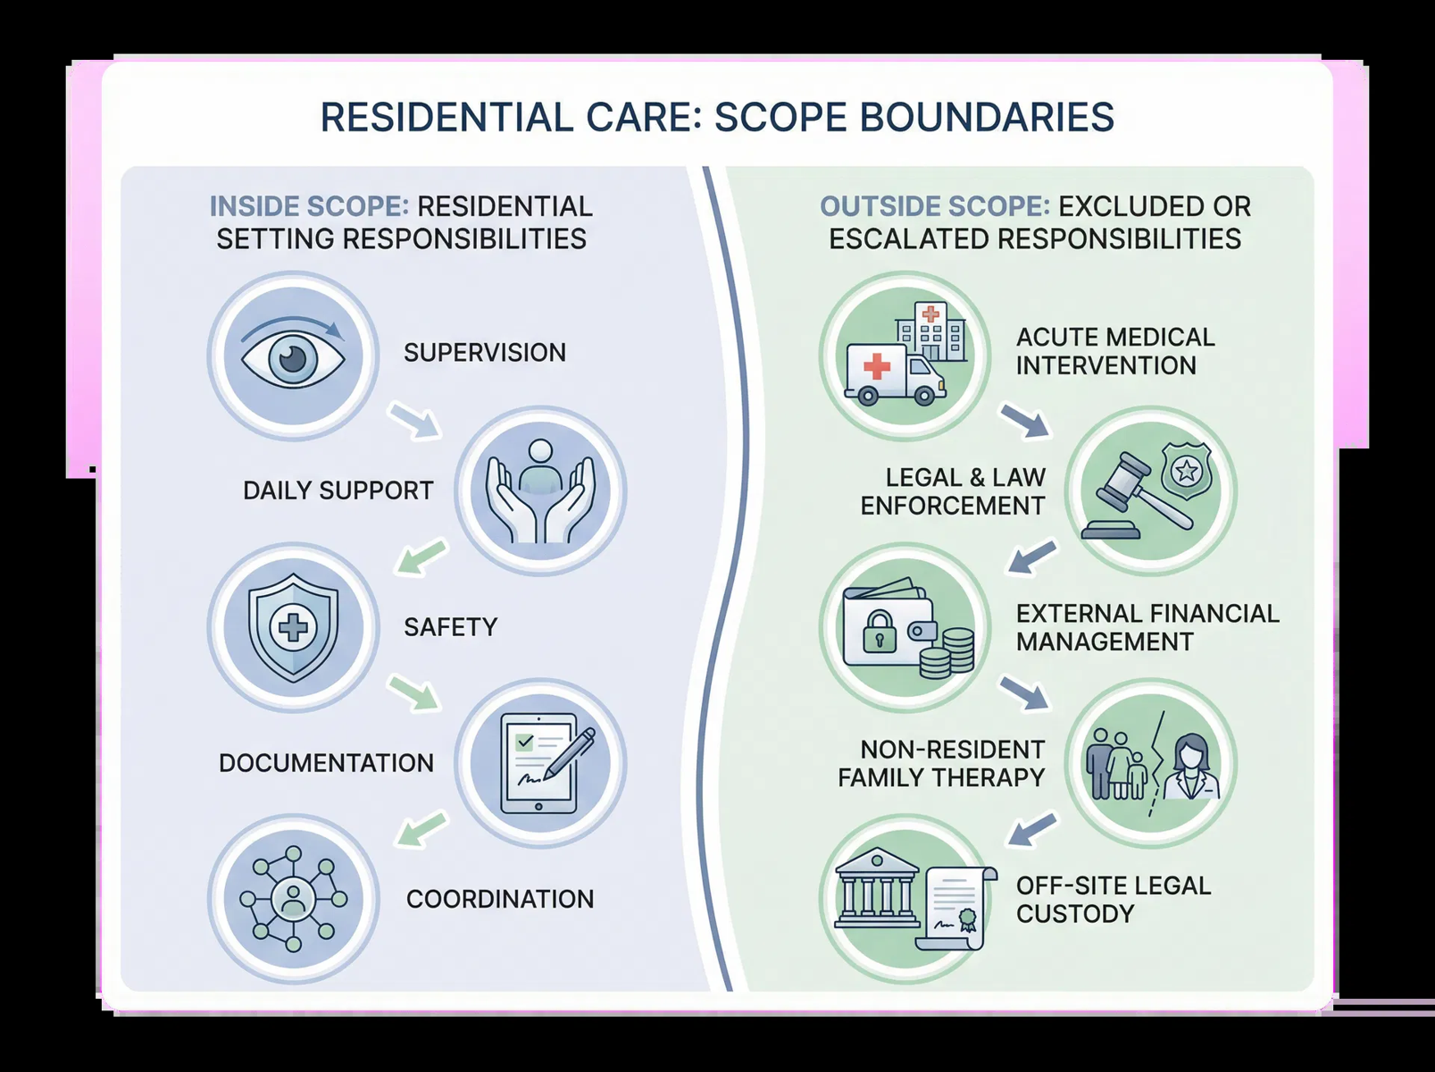
Provide an editable worksheet with realistic scenarios that help learners distinguish confident within-scope action from the need for escalation, referral, or coordination.

SECTION CONTEXT
Residential care includes supervision, structured daily support, observation, safety practices, communication, documentation, and follow-through on assigned responsibilities within the care environment. Staff should be confident in carrying out these core functions. This confidence is important because hesitation inside scope can undermine consistency, while overreach outside scope can create risk and confusion.
Boundary clarity matters because residential settings are dynamic. Staff often encounter concerns that touch clinical judgment, treatment decisions, family communication, compliance issues, crisis response, or external systems. The purpose of this section is not to discourage initiative. It is to make clear that sound initiative includes knowing when to notify, escalate, clarify, or coordinate with the appropriate person or team rather than trying to absorb every problem into the residential role.
The key lesson is that safe practice depends on both competence and restraint. Competence means carrying out residential responsibilities thoroughly and consistently. Restraint means recognizing the moment when the situation moves beyond that role and requires structured coordination. Learners should finish Module 1 understanding that role boundaries are not obstacles to care; they are part of what makes care reliable, lawful, and team-based.

RESIDENTIAL SCOPE DECISION FRAME
Framework element | Operational meaning
Manage within scope | Carry out supervision, support, documentation, observation, routine communication, and assigned care responsibilities confidently and consistently.
Coordinate across roles | Bring in the appropriate internal partners when a situation affects treatment goals, operations, continuity, or team decision-making.
Escalate when needed | Use established channels when safety concerns, urgent needs, or out-of-scope issues require higher-level direction or intervention.
Avoid role substitution | Do not replace the work of other professionals, authorities, or care settings when the matter belongs elsewhere.

KEY LEARNING TAKEAWAYS
- Confidence inside scope and discipline outside scope are both essential to safe care.
- Escalation is a sign of sound judgment, not a failure to act.
- Clear boundaries protect the client, the staff member, and the organization.
Staff should leave Module 1 able to say what residential care is responsible for, what it supports in partnership with others, and what it should never attempt to absorb alone.

HOW TO USE THIS WORKSHEET
Review each scenario during onboarding discussion or supervisor coaching. Learners should identify what they can do directly, what requires notification or coordination, and how they would explain their judgment in documentation or debrief.

SCENARIO WORKSHEET
Scenario | What is within scope now? | What must be escalated or coordinated? | Rationale
A client concern emerges that may affect safety, but the full picture is still developing.
A family member requests information that may overlap with treatment interpretation or a larger plan-of-care question.
A staff member notices a problem that could affect documentation quality and continuity across the next shift.
An issue begins as a routine residential matter but now appears to require another function’s expertise or authority.
A transition is approaching and it is unclear whether all required information has reached the next team or setting.

COACHING AND DEBRIEF NOTES
Prompt | Notes
What sign indicated that the matter was moving beyond routine residential handling?
How did the learner balance confidence inside scope with restraint outside scope?
What escalation or coordination language should the learner practice using?

FACILITATOR NOTE
This branded resource is intended to support onboarding conversation, documentation readiness, and consistent practice. It may be adapted to local workflow while preserving the section purpose, structural headings, and Adolbi Care brand treatment.

