Orientation completion note template
Module | Module 1: Enterprise and System-of-Care Orientation
Section | Section 1 — Course map and learning orientation
Document type | DOCX template
Authored by | AMOS I

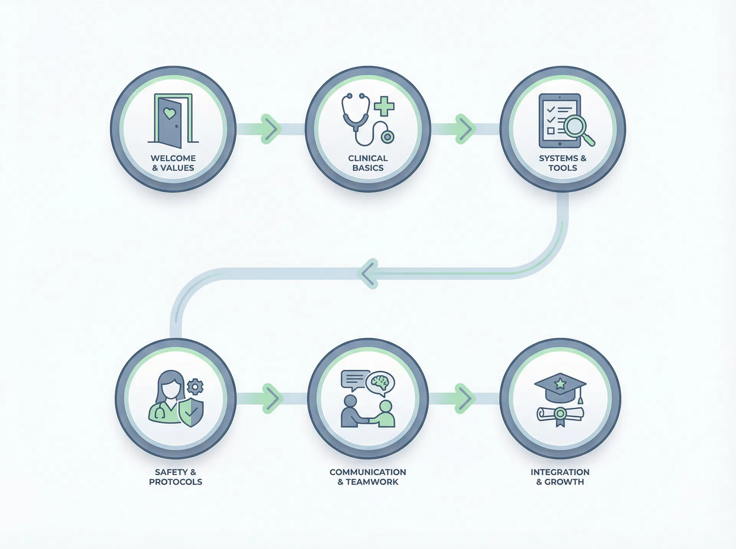
Provide an editable completion note that documents learner review of Module 1, confirms the major learning points were discussed, and captures any follow-up needs identified during supervisor review.

SECTION CONTEXT
Module 1 is the foundation course for the full orientation system. Before staff can apply governance requirements, safety expectations, documentation standards, or workflow routines, they need a clear picture of the environment in which those requirements operate. This module provides that picture by introducing the organizational setting, the service pathway, the people who carry responsibility within the system, and the limits of the residential role.
The purpose of this opening section is not simply to welcome the learner. It is to establish the frame through which every later module should be understood. Staff should leave this section knowing that their daily work is connected to larger structures of leadership, clinical coordination, treatment planning, family communication, compliance expectations, and transition planning. Without that shared frame, later instruction can feel disconnected or overly procedural.
A strong orientation process begins by answering four basic questions. Where does this site fit in the enterprise? Where does residential care fit in the client journey? How do roles connect around the work? What should staff manage directly, and what should they coordinate with others? The remaining sections of Module 1 answer those questions in sequence so learners can build understanding in a logical order.

HOW TO READ MODULE 1
Framework element | Operational meaning
Start with context | Understand the enterprise and the residential site as part of a larger operating system rather than as an isolated program.
Move through the care pathway | See how clients enter, move through, and transition across connected points of service.
Clarify responsibility | Learn how leadership, clinical, administrative, and direct-care roles contribute to safe, coordinated services.
Define boundaries | Identify where residential responsibility is appropriate and when referral, escalation, or coordination is required.

KEY LEARNING TAKEAWAYS
- State the overall purpose of Module 1 in plain language.
- Identify the four major learning questions that structure the course.
- Recognize why later modules depend on this shared foundation.
When staff understand the whole system first, later instruction becomes easier to apply. Procedures make more sense when learners know the structure, relationships, and boundaries that sit behind them.

HOW TO USE THIS TEMPLATE
Use this template after the learner completes the full Module 1 orientation sequence. It is designed to capture participation, learning confirmation, and follow-up items in a format that is easy to update and file.
The note should be completed by the facilitator or supervisor who reviewed the material with the learner. It may be adapted to local documentation practices while preserving the core completion fields and sign-off structure.

LEARNER AND SESSION DETAILS
Field | Entry
Learner name
Position/role
Department or shift
Orientation date
Reviewer/facilitator
Location | Adolbi Care — Behavioral Health Center at Cypress

SECTION VERIFICATION RECORD
Section | Completed | Key understanding demonstrated by learner
Course map and learning orientation
How the enterprise is organized
How the system of care works
How roles connect around the client
What belongs inside residential care and what does not

FOLLOW-UP ACTIONS AND SIGN-OFF
Follow-up need | Owner | Due or next review point

SUPERVISOR ATTESTATION
Signature field | Entry
Supervisor or facilitator signature
Learner signature
Date
Additional comments

FACILITATOR NOTE
This branded resource is intended to support onboarding conversation, documentation readiness, and consistent practice. It may be adapted to local workflow while preserving the section purpose, structural headings, and Adolbi Care brand treatment.

