Responsibility boundary examples
Module | Module 1: Enterprise and System-of-Care Orientation
Section | Section 4 — How roles connect around the client
Document type | DOCX practice sheet
Authored by | AMOS I

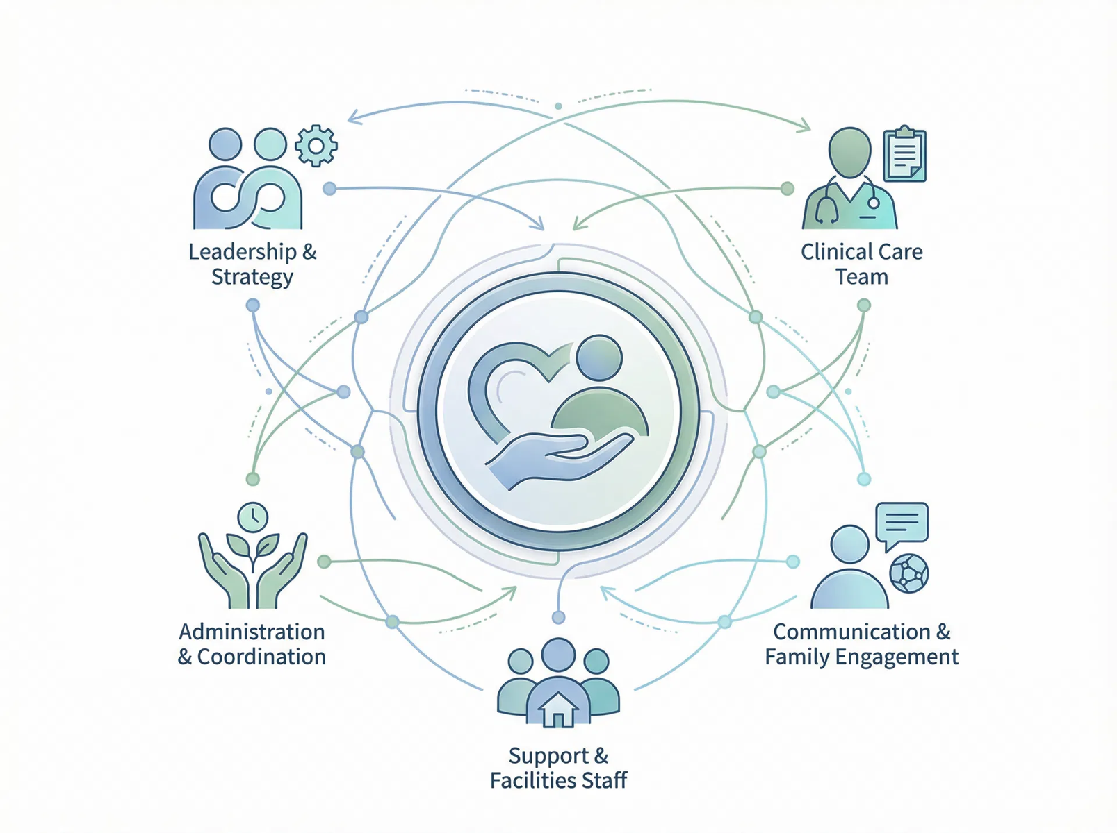
Give learners editable, scenario-based practice so they can distinguish shared accountability from role substitution or duplication.

SECTION CONTEXT
Residential care is a team-based service environment. Even when a staff member is focused on one immediate client need, that work is connected to a larger network of responsibilities that includes leadership, clinical direction, documentation expectations, operations support, and communication across disciplines. The purpose of this section is to make those relationships visible so learners understand that role clarity is a safety issue as well as an organizational one.
A common challenge in onboarding is that new staff may see job functions only through titles rather than through how work actually connects. This section reframes the picture. Leadership creates direction and accountability. Clinical roles interpret care needs and treatment implications. Administrative and operational functions support communication, logistics, and continuity. Direct-care staff translate plans and expectations into consistent daily support. No role stands alone, and no role can carry the system by itself.
The learner should finish this section with a collaborative mindset. Strong care does not mean doing everything personally. It means knowing what belongs to your role, knowing what information others need, and acting in a way that protects coordination. In that sense, communication, documentation, and handoff quality are not secondary tasks. They are part of the role structure itself.

CONNECTED ROLE PICTURE
Framework element | Operational meaning
Leadership and direction | Leadership roles define expectations, accountability lines, and the standards that guide the program’s work.
Clinical interpretation | Clinical roles help connect observed needs, treatment priorities, and care decisions to the broader service plan.
Operations and coordination | Administrative and operational functions support communication, scheduling, reporting, and continuity across the service environment.
Direct support and observation | Residential staff implement daily support, monitor client presentation, document relevant events, and communicate what others need to know.

KEY LEARNING TAKEAWAYS
- Different roles have different functions, but they support one shared client-centered purpose.
- Documentation and communication are part of accountability, not separate from it.
- Role clarity reduces duplication, confusion, and gaps in care.
The measure of strong teamwork is not whether one person can do everything. It is whether the right people receive the right information and act within the right responsibilities at the right time.

HOW TO USE THIS PRACTICE SHEET
Review each scenario and discuss what belongs within the learner’s role, what should be communicated or coordinated with another function, and what should be documented. The goal is not to produce one scripted answer, but to strengthen role clarity in realistic situations.

SCENARIO PRACTICE MATRIX
Scenario | What belongs within role | What must be coordinated or escalated | What should be documented
A staff member notices a meaningful change in a client’s presentation near the end of shift.
A family member raises a question that touches treatment direction rather than routine daily support.
A supervisor asks for clarification because different staff have communicated the same issue in different ways.
A direct-care staff member begins solving an operational problem that also affects scheduling and documentation quality.

REFLECTION AND COACHING NOTES
Prompt | Notes
Where did role clarity help the situation most?
Where was there a risk of duplication or role substitution?
What communication step would have improved coordination further?

FACILITATOR NOTE
This branded resource is intended to support onboarding conversation, documentation readiness, and consistent practice. It may be adapted to local workflow while preserving the section purpose, structural headings, and Adolbi Care brand treatment.

