Shared services orientation sheet
Module | Module 1: Enterprise and System-of-Care Orientation
Section | Section 2 — How the enterprise is organized
Document type | DOCX handout
Authored by | AMOS I

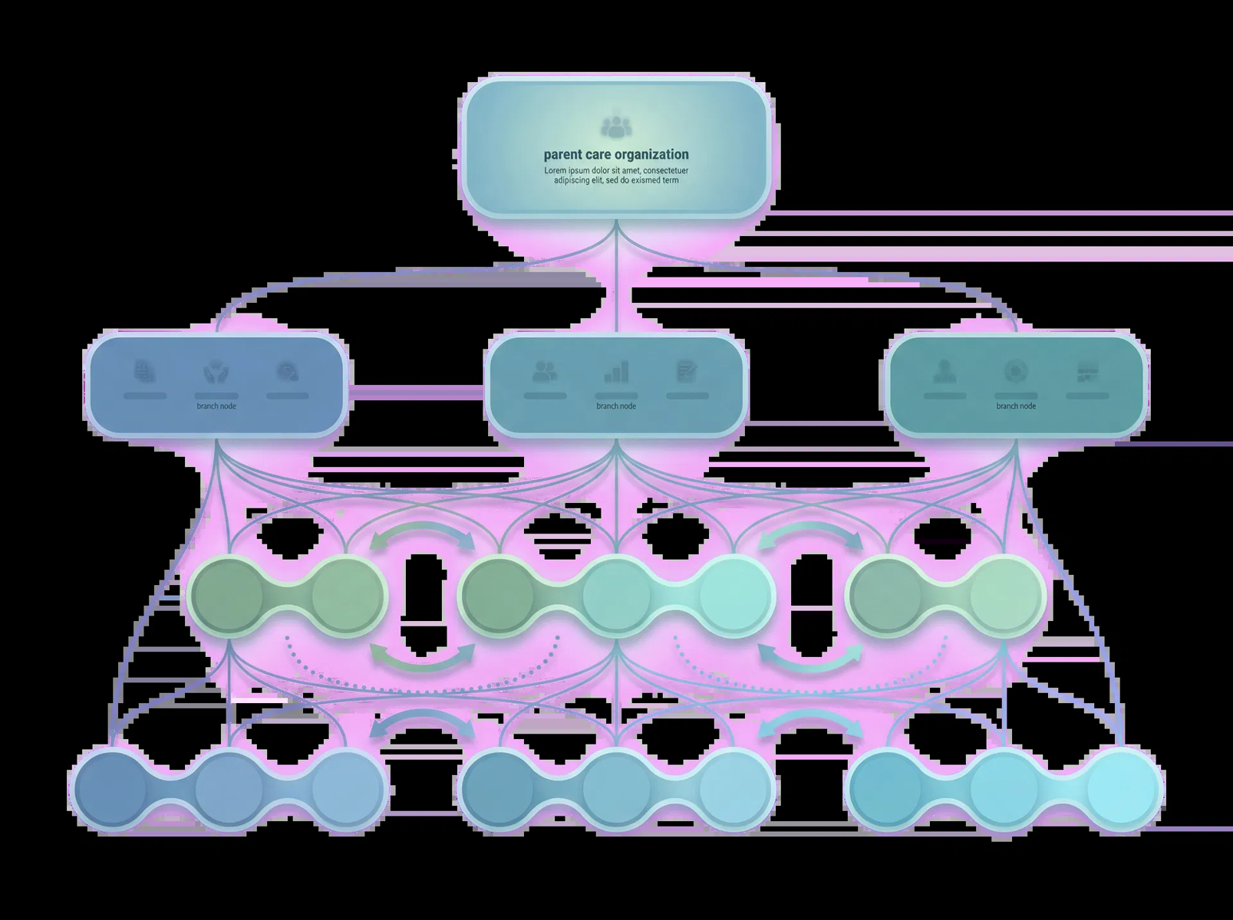
Provide an editable orientation sheet that explains how non-frontline support functions reinforce residential work and where staff may interact with those supports during onboarding and daily operations.

SECTION CONTEXT
Adolbi Care Cypress should not be understood as a stand-alone location that operates independently from the rest of the organization. It functions within an enterprise structure that links executive leadership, program leadership, administrative operations, clinical oversight, and site-level service delivery. That structure exists so that the expectations placed on frontline staff are aligned with larger organizational priorities, regulatory responsibilities, and treatment standards.
For a new learner, the most practical lesson in this section is that local decisions are rarely disconnected from enterprise accountability. Daily routines may occur at the site, but the standards that shape those routines often come from policies, leadership decisions, compliance requirements, and quality expectations that extend beyond the immediate team. Understanding that relationship helps staff interpret direction correctly and understand why consistency matters across shifts, teams, and locations.
This enterprise view also explains why shared services and support functions matter. Staffing coordination, policy communication, quality review, administrative follow-through, training, and reporting structures all help stabilize site operations. When staff see only the immediate task in front of them, they can miss how their work fits into the larger system. This section is intended to correct that by showing the site as one part of a connected organizational whole.

ENTERPRISE STRUCTURE IN PRACTICE
Framework element | Operational meaning
Leadership direction | Executive and program leadership establish priorities, standards, and accountability expectations for service delivery.
Clinical and operational oversight | Oversight functions help ensure that care practices, documentation, coordination, and supervision align with organizational expectations.
Shared support functions | Administrative, training, communication, and quality functions connect the site to the broader enterprise and keep operations stable.
Site-level execution | Residential teams carry out daily care, supervision, and coordination within the standards set by the broader organization.

KEY LEARNING TAKEAWAYS
- The site is part of a larger enterprise, not an isolated program.
- Standards, reporting lines, and expectations flow through the organization.
- Daily work at the site reflects broader leadership and support structures.
Learners should be able to explain not only who is on site, but also how site operations are supported, directed, and held accountable by the wider organization.

USING THIS ORIENTATION SHEET
Review this handout with new staff to explain that site operations are reinforced by multiple support functions beyond the immediate shift team. The goal is not to memorize departments, but to understand how support functions help maintain consistency, compliance, communication, and operational reliability.
The final column may be completed locally so the handout can reflect site-specific contacts, instructions, or onboarding notes.

SUPPORT FUNCTIONS AND WHAT THEY REINFORCE
Support function | What it reinforces | When site staff may rely on it | Local notes or contacts
Training and onboarding | Shared understanding of standards, expectations, and skill development. | When staff need orientation sequencing, refreshers, or learning follow-up.
Administration | Operational consistency, record flow, and routine coordination support. | When forms, records, approvals, or administrative steps affect local work.
Quality and compliance support | Alignment with documentation, regulatory, and quality expectations. | When staff need clarification on required processes or reporting quality.
Communication coordination | Reliable movement of information across teams and stakeholders. | When a matter needs structured follow-through beyond one shift or role.
Scheduling and staffing coordination | Coverage reliability and operational continuity. | When site staffing, shift coverage, or related continuity issues arise.
Leadership support | Interpretation of priorities, decisions, and accountability expectations. | When the situation requires direction, escalation, or organizational alignment.

ORIENTATION DISCUSSION QUESTIONS
Prompt | Discussion notes
Which support function will most often affect your daily work?
How does shared support prevent site work from becoming isolated?
What would change if the site tried to operate without reliable support functions?

FACILITATOR NOTE
This branded resource is intended to support onboarding conversation, documentation readiness, and consistent practice. It may be adapted to local workflow while preserving the section purpose, structural headings, and Adolbi Care brand treatment.

