Transition and handoff checklist
Module | Module 1: Enterprise and System-of-Care Orientation
Section | Section 3 — How the system of care works
Document type | DOCX checklist
Authored by | AMOS I

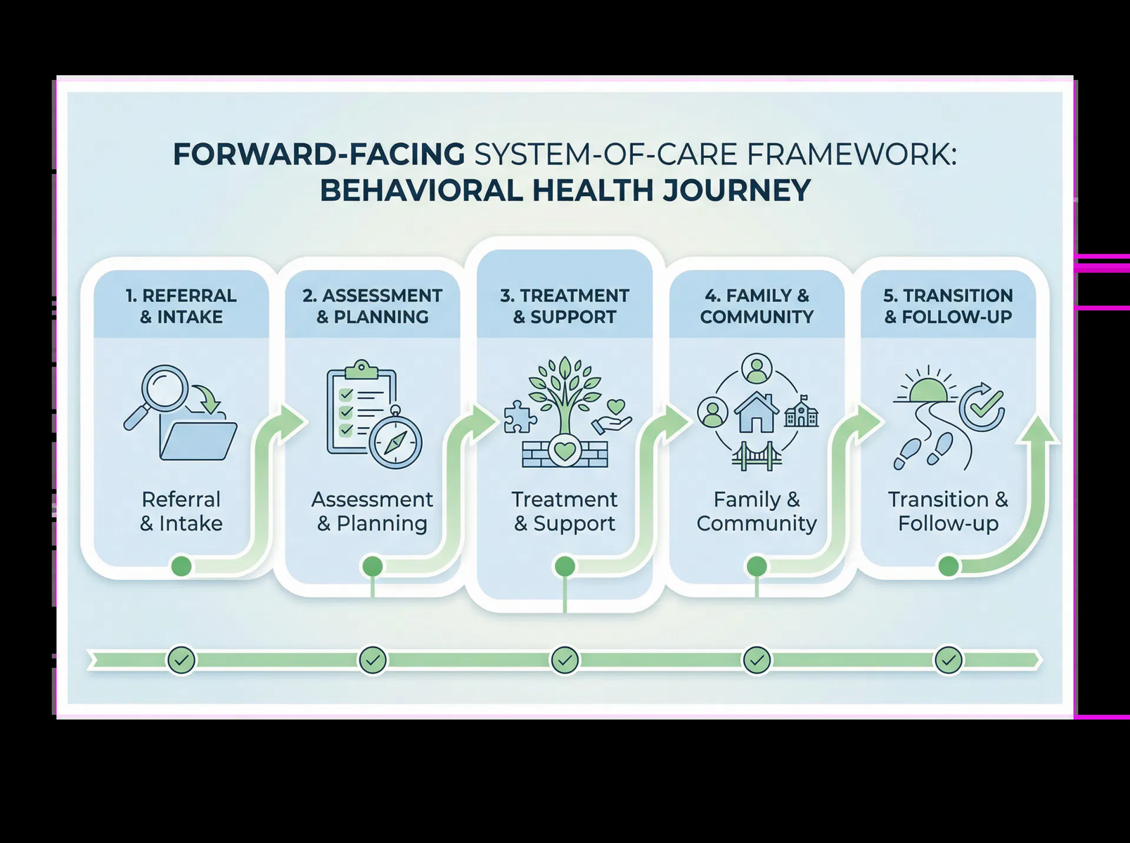
Provide an editable checklist that supports safe information transfer during transitions, internal handoffs, and coordinated movement across teams or settings.

SECTION CONTEXT
Clients do not begin and end their care experience within the residential setting alone. They move through a broader system of care that may include referral, screening, intake, assessment, treatment planning, direct service, family coordination, transition preparation, and follow-up. Residential services contribute to that continuum, but they do not replace the full set of services and decisions that occur before, during, and after the residential period.
This perspective matters because frontline misunderstandings often happen when a team treats the residential environment as the entire system. When that happens, transitions may be poorly coordinated, communication with other stakeholders may weaken, and staff may attempt to manage issues that require broader collaboration. By contrast, when staff understand the full pathway, they can better support continuity, communicate with purpose, and recognize why documentation and handoffs are essential parts of quality care.
This section should help the learner answer a practical question: where are we in the client's journey, and what does that mean for our next action? Sometimes the answer is direct residential support. At other times, the answer is preparation for transition, coordination with a treatment team, clarification of goals, or escalation of concerns. The goal is to teach staff that good care depends on understanding the stage of service, not only the immediate task.

CORE STAGES IN THE CARE PATHWAY
Framework element | Operational meaning
Entry and assessment | Referral, screening, intake, and assessment establish the starting point for service planning and decision-making.
Planning and service delivery | Treatment planning and residential support work together to provide structured care aligned with identified needs.
Coordination and family connection | Communication across teams and with relevant supports helps maintain continuity and informed care decisions.
Transition and follow-through | Preparation for next steps, handoffs, and ongoing support planning protects continuity beyond the current setting.

KEY LEARNING TAKEAWAYS
- Residential care is one part of the client's journey, not the full journey itself.
- Transitions, communication, and handoffs are central to continuity of care.
- The right action often depends on understanding the client’s stage in the pathway.
A learner should be able to pause during a real situation and ask, 'What stage of the care journey are we supporting right now, and who else must be included for the next step to be safe and effective?'

CHECKLIST INSTRUCTIONS
Use this checklist whenever a client is moving between shifts, teams, levels of coordination, or settings and a structured handoff is needed. The goal is to support continuity of care by making key information visible, accurate, and actionable.
This checklist should supplement, not replace, local documentation and notification requirements. It is intended to reinforce consistent handoff quality during orientation and real-world practice.

TRANSITION SNAPSHOT
Field | Entry
Client identifier or initials
Current stage of service
Transition or handoff date/time
Sending staff or team
Receiving staff, team, or setting
Purpose of transfer

INFORMATION TO CONFIRM BEFORE TRANSFER
Checklist item | Verified | Notes
Current status and relevant observations reviewed
Immediate safety or supervision concerns communicated
Active plan priorities or expectations clarified
Pending tasks, follow-up items, or appointments identified
Required notifications completed or assigned
Receiving party given opportunity to ask clarifying questions

RECEIVING-PARTY CONFIRMATION AND UNRESOLVED ITEMS
Prompt | Response
What does the receiving party need to monitor next?
What remains unresolved at the moment of transfer?
Who owns the next follow-up action?
How will loop closure be confirmed?

FACILITATOR NOTE
This branded resource is intended to support onboarding conversation, documentation readiness, and consistent practice. It may be adapted to local workflow while preserving the section purpose, structural headings, and Adolbi Care brand treatment.

